**Manuscript Order**

Your manuscript should be arranged in the following order:

Title, author(s), affiliation(s), abstract, keywords, **article highlights**, text, conclusion, **supplementary material section**(if any), acknowledgments, author declarations section (conflict of interest, ethics approval, and author contributions), data availability statement, appendixes (if any), and references.

**Title concise and informative title avoid abbreviations** **and formulae**

Authors

Affiliations

Corresponding authors and emails

Footnotes to the affiliations should be labeled as a), b), c), etc.

**Abstract:** A concise and factual abstract is required. The abstract should state briefly the purpose of the research, the principal results and major conclusions. An abstract is often presented separately from the article, so it must be able to stand alone. For this reason, References should be avoided, but if essential, then cite the author(s) and year(s). Also, non-standard or uncommon abbreviations should be avoided, but if essential they must be defined at their first mention in the abstract itself. Your abstract should not contain displayed equations, footnotes, references, graphics, or tables. It should be one paragraph of 250 words providing a summary of the new information, results of general interest, and conclusions.

**Keywords:** A maximum of 6 keywords, Avoiding general terms, Avoiding multiple concepts, Be sparing with abbreviations, Indexing purpose

**Article Highlights**

* Please provide three short bullet points (maximum of 120 characters (not words) each) summarizing the key findings and implications of the paper.
* These should be presented in non-technical language and not repeat verbatim text found in the abstract.
* They should be placed beneath the abstract under the heading of ‘Article Highlights’.

**1. Introduction**

State the objectives of the work and provide an adequate background, avoiding a detailed literature survey or a summary of the results1.

Please ensure that every reference cited in the text is also present in the reference list (and vice versa).2–4 Any references cited in the abstract must be given in full. Unpublished results and personal communications are not recommended in the reference list, but may be mentioned in the text. If these references are included in the reference list they should follow the standard reference style of the journal and should include a substitution of the publication date with either 'Unpublished results' or 'Personal communication'.5 Citation of a reference as 'in press' implies that the item has been accepted for publication.

**2. Experimental work**

*2.1 Material and methods*

Provide sufficient details to allow the work to be reproduced by an independent researcher. Methods that are already published should be summarized, and indicated by a reference. If quoting directly from a previously published method, use quotation marks and also cite the source. Any modifications to existing methods should also be described.

*2.2 Theory/calculation*

A Theory section should extend, not repeat, the background to the article already dealt with in the Introduction and lay the foundation for further work. In contrast, a Calculation section represents a practical development from a theoretical basis.

Nomenclature and units. Follow internationally accepted rules and conventions: use the international system of units (SI). If other quantities are mentioned, give their equivalent in SI.

Examples. The laboratory-scale reactor consists of a quartz chamber with effective treatment area dimensions of 10 cm length and 10 cm inner diameter. The plasma in this reactor operates at a frequency of 20 kHz and input voltage of up to 110 V, with a maximum output power of 100 W (Plasma Technics Inc., USA). **There should be space between numbers and the units, both in texts and in figures.**

**Abbreviations**. Define abbreviations that are not standard in this field at their first mention there. Ensure consistency of abbreviations throughout the article.

Examples. X-ray photoelectron spectroscopy (XPS) analysis was carried out using an Axis Ultra spectrometer (Kratos Analytical) with a monochromated Al Kα X-ray source.

**3. Results and discussion**

*3.1 Results*

Results should be clear and concise.

Equations – Use the built-in Microsoft® Equation Editor of Mathtype to insert math, since it needs to be editable. Displayed equations should be punctuated, aligned to bring out their structure, and numbered on the right-hand side.

Variables should be in italic. Their subscripts or superscripts, if they are also variables, should be italicized. For example, with “*Ti*, *i*=1,2,3…,” then “*i*” should be in italic. However, if the subscripts or superscripts are not variables, they should not be italicized. For example, if defining the temperature of a door and window as “*T*d” and “*T*w” then “d” and “w” should not be italicized. Variables in figures and tables should be formatted the same as in the text.

Expample:

${\text{F}}_{\text{DEP}}\text{=2π}{\text{R}}^{\text{3}}{\text{ε}}_{\text{m}}\text{Re}\text{[}\text{K}\text{(}\text{ω}\text{)]}\text{∇}{\left|{\vec{\text{E}}}_{\text{rms}}\right|}^{\text{2}}$, (1)

where *ε* is the dielectric constant; *E*rms is the root mean square value of the light-induced on-uniform electric field; *ω* is the angular frequency of the AC bias potential in the liquid medium; *K*(*ω*) is the clusius-mossotti (CM) factor.

The natural logarithm base “e”, imaginary unit “i”, and pi “π” (when it equals 3.14159…) should not be bold or italic. Vectors and matrices should be both bold and italic.

Points, lines and planes should be written in italic. For example, point *P*(*m*,*n*).

*3.2 Discussion*

This should explore the significance of the results of the work, not repeat them. A combined Results and Discussion section is often appropriate. Avoid extensive citations and discussion of published literature.

Figures – Please insert all figure images into the main body near the figure callout.

Ensure that each illustration has a caption, as shown in Fig.1. Supply captions separately, not attached to the figure. Keep text in the illustrations themselves to a minimum but explain all symbols and abbreviations used. Submit illustrations in the size and resolution you wish them to appear in print.

The maximum published width for a one-column figure is 3.37 inches (8.5 cm). The maximum width for a two-column figure is 6.69 inches (17 cm). The maximum depth of figures should be 8 ¼ in. (21.1 cm). Legends or labels within figures should be a minimum of 8-point type size (2.8 mm high; 1/8 in. high). A minimum of 0.5-point width for lines.

Required Highlight Image

To establish a strong and consistent visual identity for your article, a highlight image is required with your revised submission. It can be either a figure from your paper or another image you create that reflects your work. This image should measure 8.0139 in. wide × 6.2739 in. high and be a minimum of 300 dpi. Your highlight image will display above your article title in the Table of Contents online.

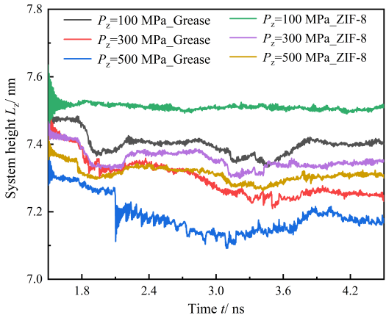

Fig.1The change in *L*z with time during compression

Figure 2 shows the Color artwork. Please make sure that artwork files are in an acceptable format (TIFF (or JPEG), EPS (or PDF) or MS Office files) and with the correct resolution. Identify all figure parts with (a), (b), etc. Avoid any large size differences of the lettering and labels used within one illustration.

Set the graphic for:

Line art: 600 dpi resolution and black/white bitmap, not grayscale.

Halftones: 264 dpi and grayscale, not black/white bitmap.

Combinations (line art and halftone): 600 dpi for and grayscale, not black/white bitmap.

Color online: 300 dpi TIFF, PS, or EPS format. If selecting a file mode, use RGB (red, green, blue).

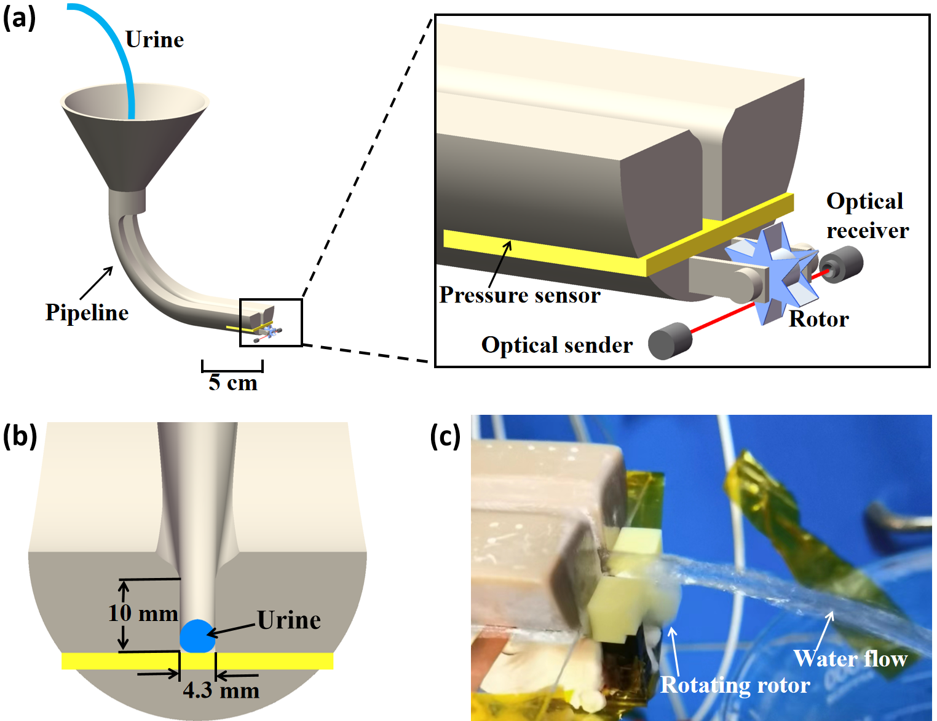

Fig.2 The design of uroflowmeter: (a) The diagram of the uroflowmeter; (b) Urine flows over the sensor surface embedded in the pipeline; (c) The rotor rotates due to the impact of water. **Please capitalize the initial letter of the first word in the items.**

Tables – Use Word’s “Insert Table” function for proper typesetting. Tables should be embedded in the text. Tables should have a caption and be cited in text and numbered consecutively, i.e., I, II, III, etc. Footnotes in tables should be labeled as a), b), c), etc.

Units should be noted in column headings. If using bold font to emphasize table data, include an explanation, i.e., “Boldface denotes…” Unaltered computer output cannot be accepted.

Table 1Parameters of L-J potential

|  |  |  |
| --- | --- | --- |
| Atom | *ε* (kcal/mol) | *σ* (nm) |
| C1-C1 | 0.01983 | 0.468 |
| Fe-Zn | 0.34222 | 0.255 |
| Fe-Li | 0.30716 | 0.261 |

**4. Conclusions**

The main conclusions of the study may be presented in a short Conclusions section, which may stand alone or form a subsection of a Discussion or Results and Discussion section. The main conclusions of the study may be presented in a short Conclusions section, which may stand alone or form a subsection of a Discussion or Results and Discussion section.

### Supplementary Material

Data tables and/or text that are too long or may be of limited interest to readers can be included as “supplementary material,” which can aid the reviewer and be accessed by readers online after publication.

If you are uploading supplementary material, please note the following:

* Please create a “Supplementary Material” section in your paper after the Conclusions. Within this section, you can provide a brief description of this information.
* Note that any mention of this information within the body of your paper should use the phrase “**supplementary material**,” so readers can access it.
* At initial submission, please upload your supplementary material in a pdf (SI.pdf), as it needs to be approved by the Journal Editor as part of the manuscript’s peer review process.

**Acknowledgments**

List funding sources in this standard way to facilitate compliance to funder's requirements:

Funding: This work was supported by the National Institutes of Health [grant Nos. xxxx, yyyy] and the United States Institutes of Peace [grant No. aaaa].

**Comflict of interest**

None.

**Data avalability**

All research articles must include a data availability statement informing where the data can be found. By data we mean the minimal dataset that would be necessary to interpret, replicate and build upon the findings reported in the article. Search “data availability statement” in <https://publishing.aip.org/resources/researchers/author-instructions/> to find the templates.

**References**

If you are including material that has been previously published (e.g., illustrations), you are required to obtain permission from the original publisher or copyright holder to reuse that material. Re-use of material from an author's previously published work may still require permission from the original publisher.

If you have not already done so, contact the original publisher or the appropriate copyright holder immediately to obtain the necessary permissions. A helpful guide is provided [**here**](https://publishing.aip.org/resources/researchers/rights-and-permissions/permissions/).

Reference to a journal publication:

1. Liang S, Xiang F, Tang F, et al. [Noise in nanopore sensors: Sources, models, reduction, and benchmarking](https://www.sciencedirect.com/science/article/pii/S2589554019300546). Nano Prec Eng 2020;3(1):9-17. <https://doi.org/10.1016/j.npe.2019.12.008>

Reference to a journal publication with an article number:

2. Saha B, Das B and Majumder M. A deep-reinforcement learning approach for optimizing homogeneous droplet routing in digital microfluidic biochips. Nano Prec Eng 6, 023001 (2023); <https://doi.org/10.1063/10.0017350>.

Reference to a book:

3. Strunk W Jr, White EB. The Elements of Style. 4th ed. New York, NY: Longman; 2000.

Reference to a chapter in an edited book:

4. Mettam GR, Adams LB. How to prepare an electronic version of your article. In: Jones BS, Smith RZ, eds. Introduction to the Electronic Age. New York, NY: E-Publishing Inc; 2009:281–304.

Reference to a website:

5. Cancer Research UK. Cancer statistics reports for the UK. http://www.cancerresearchuk.org/aboutcancer/statistics/cancerstatsreport/; 2003 Accessed 13 March 2003.

Reference to a dataset:

[dataset] 6. Oguro, M, Imahiro, S, Saito, S, Nakashizuka, T. Mortality data for Japanese oak wilt disease and surrounding forest compositions, Mendeley Data, v1; 2015. <https://doi.org/10.17632/xwj98nb39r.1.>

**Author photo and biography**

Please provide the photos and short bios of authors here.

**More information please refer to the Guide to Authors:** [**https://publishing.aip.org/resources/researchers/author-instructions/**](https://publishing.aip.org/resources/researchers/author-instructions/)