**Title concise and informative title avoid abbreviations** **and formulae**

Author names and affiliations

Corresponding authors and emails

**Abstract:**  A concise and factual abstract is required. The abstract should state briefly the purpose of the research, the principal results and major conclusions. An abstract is often presented separately from the article, so it must be able to stand alone. For this reason, References should be avoided, but if essential, then cite the author(s) and year(s). Also, non-standard or uncommon abbreviations should be avoided, but if essential they must be defined at their first mention in the abstract itself. A concise and factual abstract is required. The abstract should state briefly the purpose of the research, the principal results and major conclusions. An abstract is often presented separately from the article, so it must be able to stand alone. For this reason, References should be avoided, but if essential, then cite the author(s) and year(s). Also, non-standard or uncommon abbreviations should be avoided, but if essential they must be defined at their first mention in the abstract itself.

**Keywords:** A maximum of 6 keywords, Avoiding general terms, Avoiding multiple concepts, Be sparing with abbreviations, Indexing purpose

**Article Highlights**

* Please provide three short bullet points (maximum of 120 characters (not words) each) summarizing the key findings and implications of the paper.
* These should be presented in non-technical language and not repeat verbatim text found in the abstract.
* They should be placed beneath the abstract under the heading of ‘Article Highlights’.

**1. Introduction**

State the objectives of the work and provide an adequate background, avoiding a detailed literature survey or a summary of the results1.

It is important that the file be saved in the native format of the word processor used. Keep the layout of the text as simple as possible. Most formatting codes will be removed and replaced on processing the article. In particular, do not use the word processor's options to justify text or to hyphenate words. However, do use bold face, italics, subscripts, superscripts etc. The electronic text should be prepared in a way very similar to that of conventional manuscripts. Note that source files of figures, tables and text graphics will be required whether or not you embed your figures in the text. See also the section on Electronic artwork. To avoid unnecessary errors you are strongly advised to use the 'spell-check' and 'grammar-check' functions of your word processor.

Please ensure that every reference cited in the text is also present in the reference list (and vice versa).2–4 Any references cited in the abstract must be given in full. Unpublished results and personal communications are not recommended in the reference list, but may be mentioned in the text. If these references are included in the reference list they should follow the standard reference style of the journal and should include a substitution of the publication date with either 'Unpublished results' or 'Personal communication'.5 Citation of a reference as 'in press' implies that the item has been accepted for publication.

**2. Experimental work**

*2.1 Material and methods*

Provide sufficient details to allow the work to be reproduced by an independent researcher. Methods that are already published should be summarized, and indicated by a reference. If quoting directly from a previously published method, use quotation marks and also cite the source. Any modifications to existing methods should also be described.

*2.2 Theory/calculation*

A Theory section should extend, not repeat, the background to the article already dealt with in the Introduction and lay the foundation for further work. In contrast, a Calculation section represents a practical development from a theoretical basis.

Nomenclature and units. Follow internationally accepted rules and conventions: use the international system of units (SI). If other quantities are mentioned, give their equivalent in SI.

Examples. The laboratory-scale reactor consists of a quartz chamber with effective treatment area dimensions of 10 cm length and 10 cm inner diameter. The plasma in this reactor operates at a frequency of 20 kHz and input voltage of up to 110 V, with a maximum output power of 100 W (Plasma Technics Inc., USA). **There should be space between numbers and the units, both in context and in figures.**

Abbreviations. Define abbreviations that are not standard in this field in a footnote to be placed on the first page of the article. Such abbreviations that are unavoidable in the abstract must be defined at their first mention there, as well as in the footnote. Ensure consistency of abbreviations throughout the article.

Examples. X-ray photoelectron spectroscopy (XPS) analysis was carried out using an Axis Ultra spectrometer (Kratos Analytical) with a monochromated Al Kα X-ray source. This technique was used to investigate changes in surface chemistry after plasma treatment of both ABS and PP. Optical emission spectroscopy (OES) was used as a diagnostic tool to monitor changes in atomic and molecular species in response to changes in the experimental conditions. In this study, spectra from the plasma discharge were obtained in the 200–850 nm region using an Ocean Optics USB4000 UV/VIS spectrometer.

**3. Results and discussion**

*3.1 Results*

Results should be clear and concise. Results should be clear and concise. Results should be clear and concise. Results should be clear and concise. Results should be clear and concise. Results should be clear and concise. Results should be clear and concise.

Variables should be italicized, while the superscripts and subscripts should be italic or not depending on whether it is a variable or not:

${\text{F}}_{\text{DEP}}\text{=2π}{\text{R}}^{\text{3}}{\text{ε}}_{\text{m}}\text{Re}\text{[}\text{K}\text{(}\text{ω}\text{)]}\text{∇}{\left|{\vec{\text{E}}}_{\text{rms}}\right|}^{\text{2}}$ (1)

where *ε* is the dielectric constant; *E*rms is the root mean square value of the light-induced on-uniform electric field; *ω* is the angular frequency of the AC bias potential in the liquid medium; *K*(*ω*) is the clusius-mossotti (CM) factor, which is an important indicator for determining the direction of the dielectrophoretic force.

*3.2 Discussion*

This should explore the significance of the results of the work, not repeat them. A combined Results and Discussion section is often appropriate. Avoid extensive citations and discussion of published literature.

Figure captions. Ensure that each illustration has a caption, as shown in Fig.1. Supply captions separately, not attached to the figure. A caption should comprise a brief title (not on the figure itself) and a description of the illustration. Keep text in the illustrations themselves to a minimum but explain all symbols and abbreviations used.

The maximum published width for a one-column figure is 3.37 inches (8.5 cm). The maximum width for a two-column figure is 6.69 inches (17 cm). The maximum depth of figures should be 8 ¼ in. (21.1 cm). Legends or labels within figures should be a minimum of 8-point type size (2.8 mm high; 1/8 in. high). A minimum of 0.5-point width for lines.

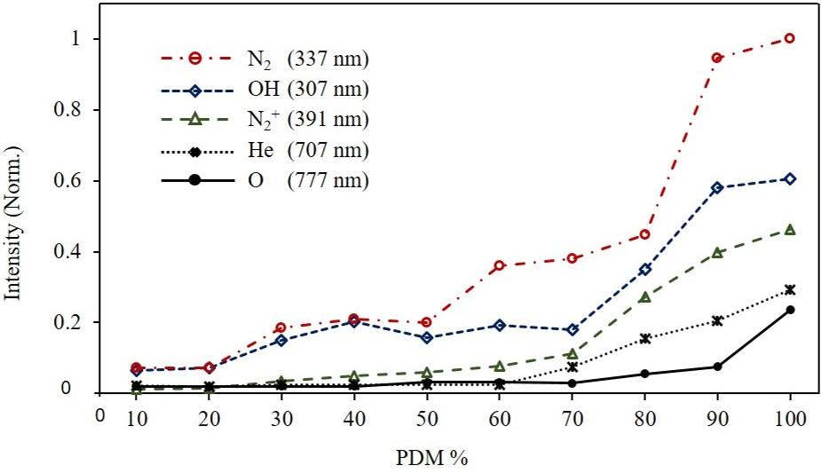

Fig.1 Effect of PDM% on the plasma species intensities obtained by OES

Figure 2 shows the Color artwork. Please make sure that artwork files are in an acceptable format (TIFF (or JPEG), EPS (or PDF) or MS Office files) and with the correct resolution. Identify all figure parts with (a), (b), etc. Avoid any large size differences of the lettering and labels used within one illustration.

Set the graphic for:

Line art: 600 dpi resolution and black/white bitmap, not grayscale.

Halftones: 264 dpi and grayscale, not black/white bitmap.

Combinations (line art and halftone): 600 dpi for and grayscale, not black/white bitmap.

Color online: 300 dpi TIFF, PS, or EPS format. If selecting a file mode, use RGB (red, green, blue).

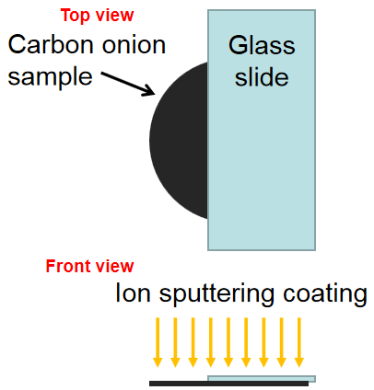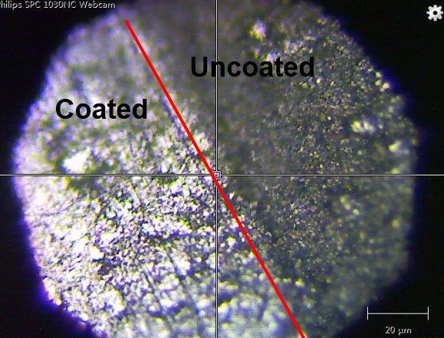

**(b)**

**(a)**

Fig.2. (a) Schematic diagram of coating process prior to the Raman measurement; (b) optical microscopy image of the boundary between the coated and uncoated areas of the sample annealed at 1700 °C. **Please capitalize the initial letter of the first word in the items.**

Please submit tables as editable text and not as images, as shown in Table 1. Tables can be placed either next to the relevant text in the article, or on separate page(s) at the end. Number tables consecutively in accordance with their appearance in the text and place any table notes below the table body. Be sparing in the use of tables and ensure that the data presented in them do not duplicate results described elsewhere in the article. Please avoid using vertical rules and shading in table cells.

Table 1 Elemental composition of ABS and PP before and after plasma treatment.

|  |  |  |  |  |  |  |
| --- | --- | --- | --- | --- | --- | --- |
| Samples | | %C | %O | %N | C:O | C:N |
| ABS | Before treatment | 92.7 | 2.8 | 3.8 | 33.1 | 24.4 |
| Laboratory-scale reactor | 84.8 | 11.3 | 3.9 | 7.5 | 21.7 |
| Pilot-scale reactor | 82.9 | 12.4 | 4.5 | 6.7 | 18.5 |
| PP | Before treatment | 89.7 | 10.1 |  | 8.8 |  |
| Laboratory-scale reactor | 87.2 | 12.5 |  | 6.9 |  |
| Pilot-scale reactor | 83.2 | 14.6 |  | 5.7 |  |

**4. Conclusions**

The main conclusions of the study may be presented in a short Conclusions section, which may stand alone or form a subsection of a Discussion or Results and Discussion section. The main conclusions of the study may be presented in a short Conclusions section, which may stand alone or form a subsection of a Discussion or Results and Discussion section.

**Acknowledgments**

List funding sources in this standard way to facilitate compliance to funder's requirements:

Funding: This work was supported by the National Institutes of Health [grant numbers xxxx, yyyy] and the United States Institutes of Peace [grant number aaaa].

**Comflict of interest**

None.

**Data avalability**

All research articles must include a data availability statement informing where the data can be found. By data we mean the minimal dataset that would be necessary to interpret, replicate and build upon the findings reported in the article. Search “data availabiligy statement” in <https://aip.scitation.org/npe/authors/manuscript> to find the templates.

**References**

If you are including material that has been previously published (e.g., illustrations), you are required to obtain permission from the original publisher or copyright holder to reuse that material. Re-use of material from an author's previously published work may still require permission from the original publisher.

If you have not already done so, contact the original publisher or the appropriate copyright holder immediately to obtain the necessary permissions. A helpful guide is provided **[here](http://publishing.aip.org/authors/author-permission-faq" \t "_blank)**.

Reference to a journal publication:

1. Liang S, Xiang F, Tang F, et al. [Noise in nanopore sensors: Sources, models, reduction, and benchmarking](https://www.sciencedirect.com/science/article/pii/S2589554019300546). Nano Prec Eng 2020;3(1):9-17. <https://doi.org/10.1016/j.npe.2019.12.008>

Reference to a journal publication with an article number:

2. Saha B, Das B and Majumder M. A deep-reinforcement learning approach for optimizing homogeneous droplet routing in digital microfluidic biochips. Nano Prec Eng 6, 023001 (2023); <https://doi.org/10.1063/10.0017350>.

Reference to a book:

3. Strunk W Jr, White EB. The Elements of Style. 4th ed. New York, NY: Longman; 2000.

Reference to a chapter in an edited book:

4. Mettam GR, Adams LB. How to prepare an electronic version of your article. In: Jones BS, Smith RZ, eds. Introduction to the Electronic Age. New York, NY: E-Publishing Inc; 2009:281–304.

Reference to a website:

5. Cancer Research UK. Cancer statistics reports for the UK. http://www.cancerresearchuk.org/aboutcancer/statistics/cancerstatsreport/; 2003 Accessed 13 March 2003.

Reference to a dataset:

[dataset] 6. Oguro, M, Imahiro, S, Saito, S, Nakashizuka, T. Mortality data for Japanese oak wilt disease and surrounding forest compositions, Mendeley Data, v1; 2015. <https://doi.org/10.17632/xwj98nb39r.1.>

**More information please refer to the Guide to Authors:** <https://aip.scitation.org/npe/authors/manuscript>

**Author photo and biography**