Author Guidelines
Proof of Concept and Protype article submission to APL Energy

The length of the manuscript should not exceed 2000 words and must include the following:

- Title
- Authors and author affiliations
- Abstract
- Provide a short description of your project, explaining the idea, and the expected outcomes.
- Introduction
- Problem. Describe the challenge or need that the idea aims to solve or alleviate.
- State of the art. Describe the status of current technology in use to address this challenge, if any.
- Solution. Provide a brief description of the proposed innovation. A clear value proposition should be included that explains how the idea tackles a societal challenge.
- This section should be understandable for a non-specialist in the field.
- Research excellence
- Describe the potential for innovation, business inventiveness, and real-world application of your idea.
- Include a detailed description of how the project outcomes will be innovative or unique compared to what already exists.
- Describe any competing products or solutions. State why potential users or sponsors should choose this solution as opposed to other existing solutions.
- Demonstration level
- Technology Readiness Levels (TRLs) estimate the maturity level of a particular technology.
- Describe the Technology Readiness Level of your proposed technological innovation.
- Discuss challenges that may be difficult to overcome or aspects that may require further development.
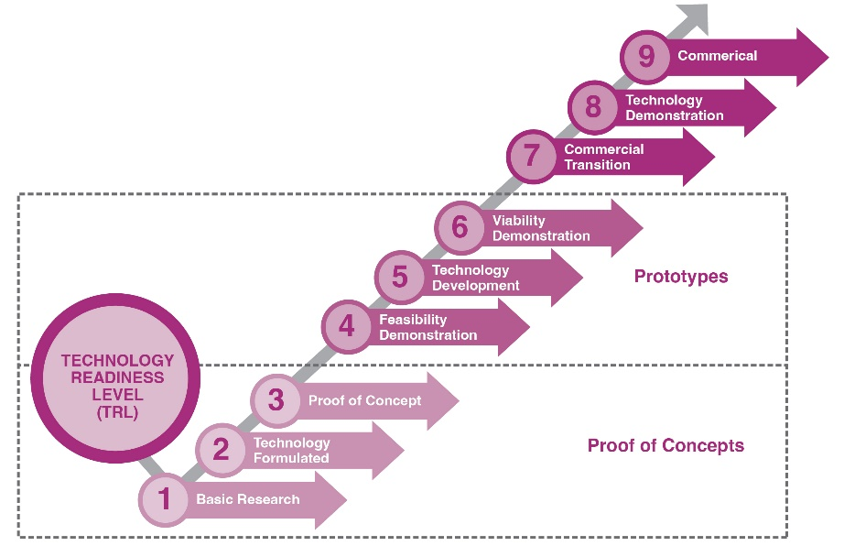

- Level of intellectual property (IP) management and protection
- Describe the level of protection of the technology. For example, is this a patent, trade secret, utility model, industrial design, trademark, copyright, etc. Please provide the reference number.
- Future applicability and Technology Readiness Level
- For technologies that require further development, describe the final Technology Readiness Level (TRL) that can be achieved.
- Elaborate upon the next steps, the improvements required, and next-level demonstration.
- Discuss stakeholders or investors who are already involved in the process or those who may contribute to advancing the technology. Describe the financial potential of the technology.
- Market considerations
- Briefly describe the time-to-market, size, supply/demand situation, discounted cash flow (DCF), expected return on investment (ROI), and existing competition.
10. Conclusion
11. Author Contribution Statement, Conflict of Interest, Funding, Acknowledgements, References
All non-essential figures, tables, data, code, procedures, and protocols should be included as supplementary material.
AIP Publishing is committed to ensuring confidentiality of sensitive and proprietary information. All authors, at the time of submission, will be required to submit a statement indicating that the contents of the manuscript are cleared for public release and that the appropriate approvals were maintained prior to submission.
Note: APL Energy is an open access journal. Articles published in APL Energy are freely accessible, without restrictions, to the global public. Authors who wish to publish a Proof of Concept and Prototype article should not disclose any confidential information. Authors who wish to publish in APL Energy retain the copyright to their work under a Creative Commons license. Under this license, users are free to share and adapt the material in any format, provided appropriate credit is given.

https://www.investopedia.com/terms/d/dcf.asp

